LABORATORY 3 – REPORT

## Sahil Mehra - 16403142 - ECE1

*I hereby declare that the attached submission is all my own work, that it has not previously been submityeted for assessment, and that I have not knowingly allowed it to be used by another student. I understand that deceiving or attempting to deceive examiners by passing off the work of another as one's own is not permitted. I also understand that using another's student’s work or knowingly allowing another student to use my work is against the University regulations and that doing so will result in loss of marks and possible disciplinary proceedings.*

Note: Coursework examiners are entitled to reject any coursework which does not have a signed copy of this form attached or are submitted late.

## Problem 1

The aim of this problem is to write a C program that reads data from a text file and interprets the data and calculates the tax for each car depending on certain conditions

### Plan

* Create a struct with year, car number, colour and engine size
* Declare welcoming message and functions
* Open the indata.txt
* Scan the contents of indata.txt and save them in the struct
* Calculate the tax
* Print the tax to the screen
* Close the indata.txt file

### Development

The first step in the development of my program was to include the standard C libraries (stdio.h, stdlib.h,) that in order to be able to use certain functions in the program.

I then declared my struct with year, car number, colour and engine size. I also declared a function for a user menu and tax.

Then, I started writing up the main function of the program. I opened the indata.txt file and I used the for loop, in the for loop ‘fscanf’ to scan the contents of the file and save it to the struct. I then called the function tax from int main(). In this function I used a for loop with nested if statements to determine what tax a car would receive per year. I then used used a printf statement to print the tax for each car to the screen

### Testing

I compiled and tested the program using the gcc compiler. I was not presented any errors when I compiled my code.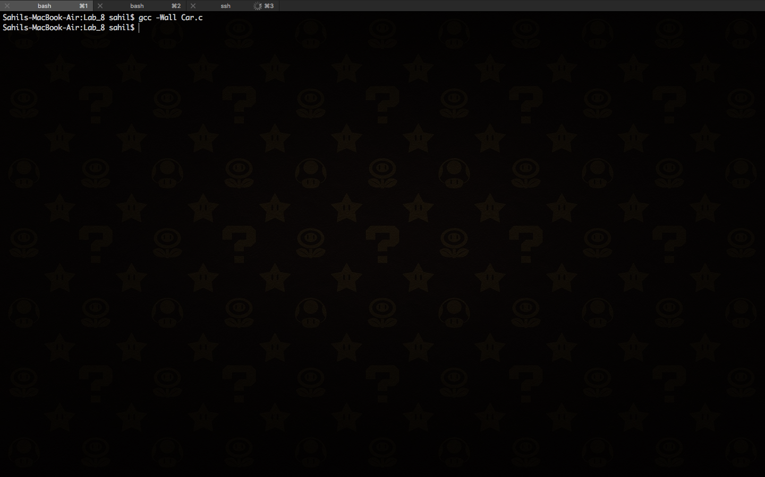

The program ran smoothly without any errors

### Conclusion

During this lab session I learned about some of the functions contained in the stdio.h and stdlib.h libraries (e.g. int functions).

## Problem 2

The aim of this problem is to amend the code for the previous problem to store the tax in the struct as well and to include a user menu to determine whether to print the tax to the screen or to a separate file.

### Plan

* Use the code from the previous question
* Change the struct to store tax
* Open the outdata.txt file
* Ask the user where to store the tax.

### Development

The first step in the development of my program was to include add an ‘int tax’ to the struct. I then declared a void function called ‘void user_menu()’. I then removed the printf statement from int main and instead called ‘user_menu’. In ‘user_menu’ I used three printf statements to give the user the options and then I used a scanf statement to store the choice. I used a switch statement and based on the number the user put in the programme did different things. For all three cases I called used a for loop and the function ‘tax’ and calculated the tax for each car. I then printed the tax on the screen and/or I stored the tax in a file called ‘outdata.txt’. I did this using a fprintf statement.

### Testing

I compiled and tested the program using the gcc compiler. I was not presented any errors when I compiled my code.



The code ran smoothly without any errors as shown below.

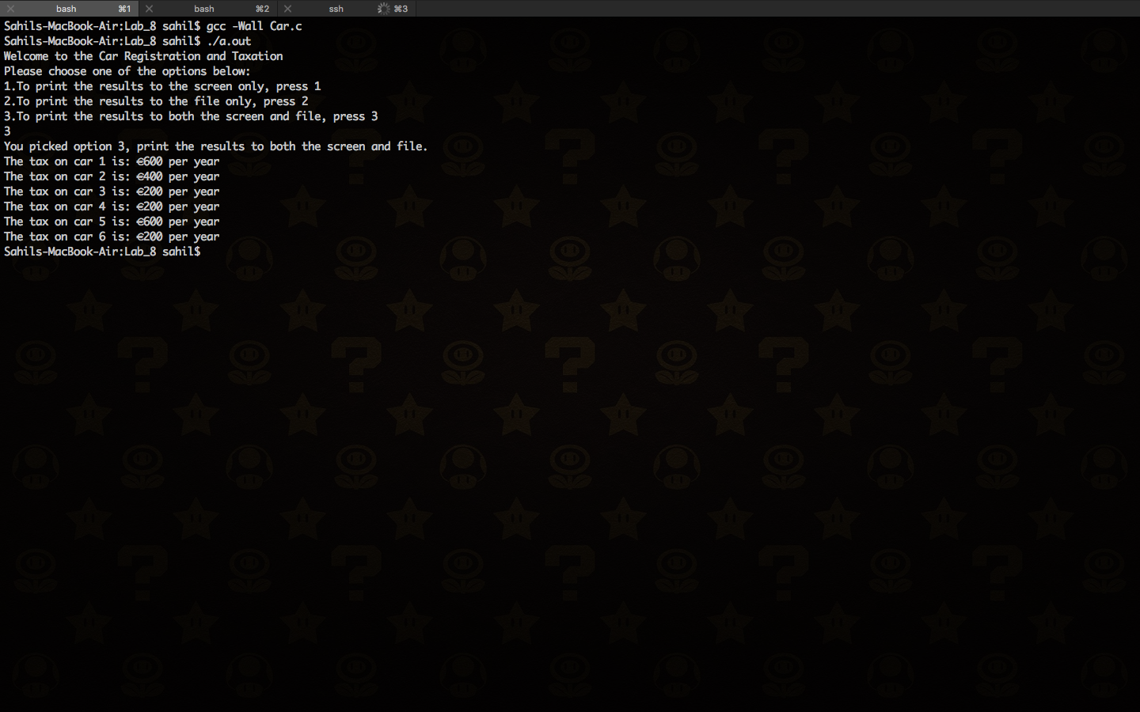

### Conclusion

During this lab session I learned about some of the functions contained in the stdio.h, stdlib.h and string.h libraries (e.g. if statements)..

The final version of the C source code for problem 1 and 2 is attached as Car.c